# Use Case Diagram

## Use Case Diagram Admin

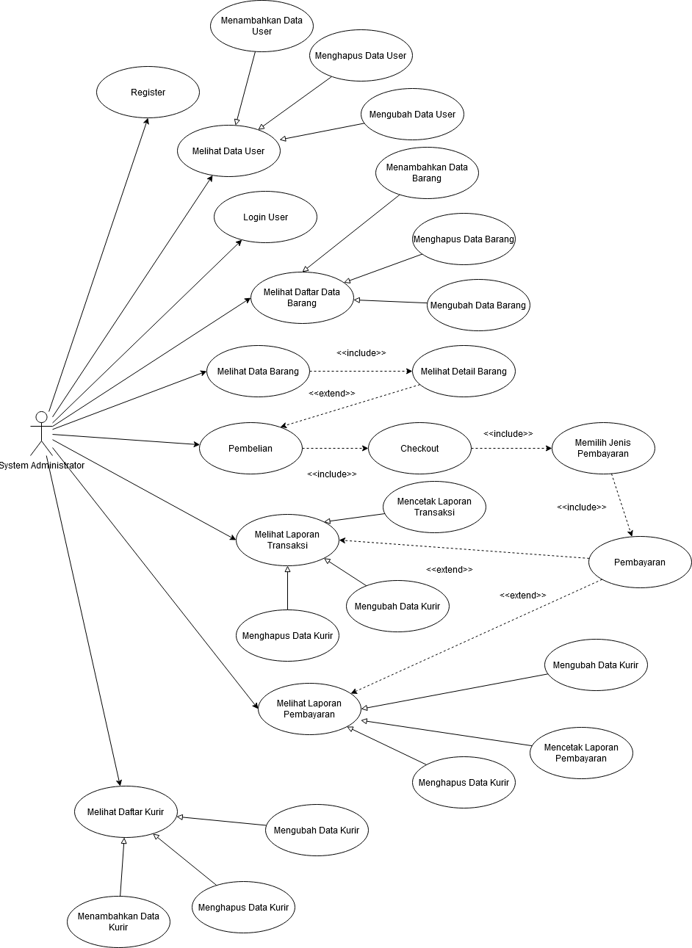

## Use Case Diagram Penjual

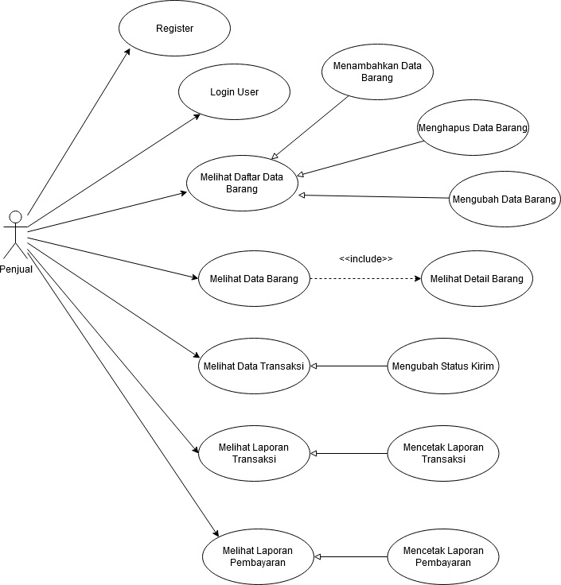

## Use Case Diagram Pembeli

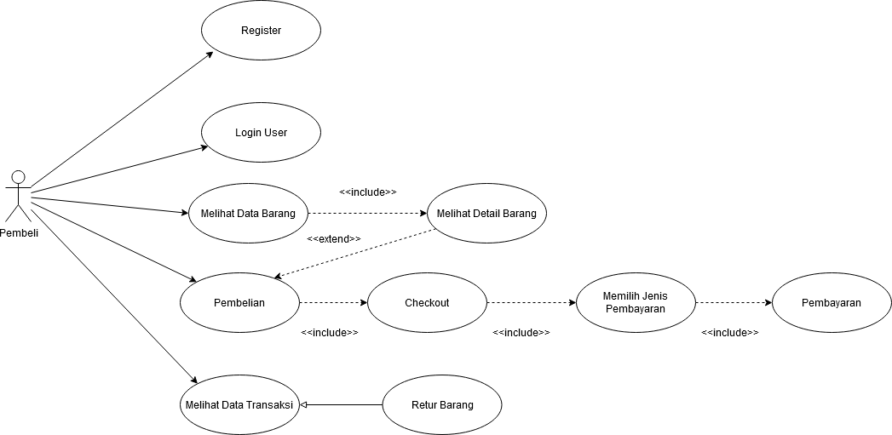

## Use Case Diagram Pengunjung

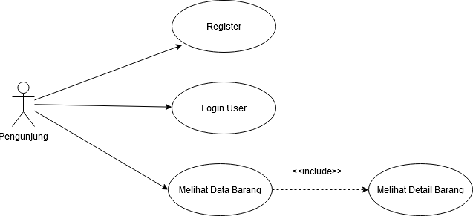

# Activity Diagram

## Activity Diagram Register

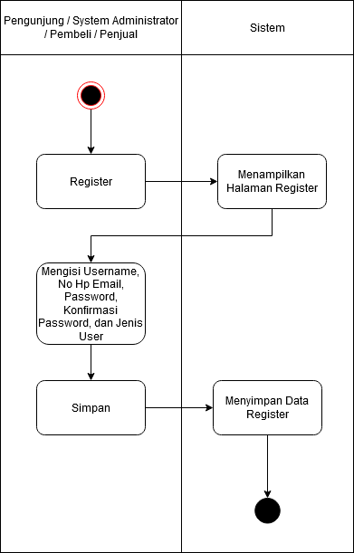

## Activity Diagram Menambah Data User

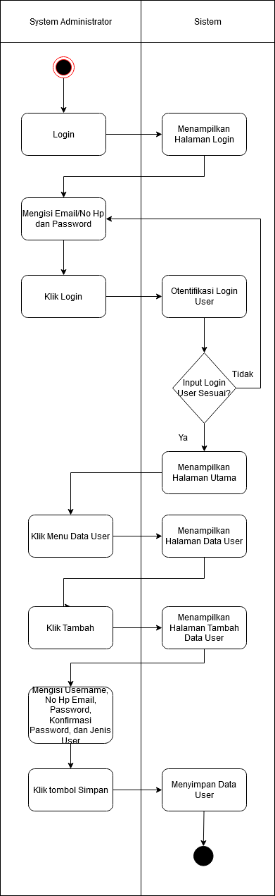

## Activity Diagram Mengubah Data User

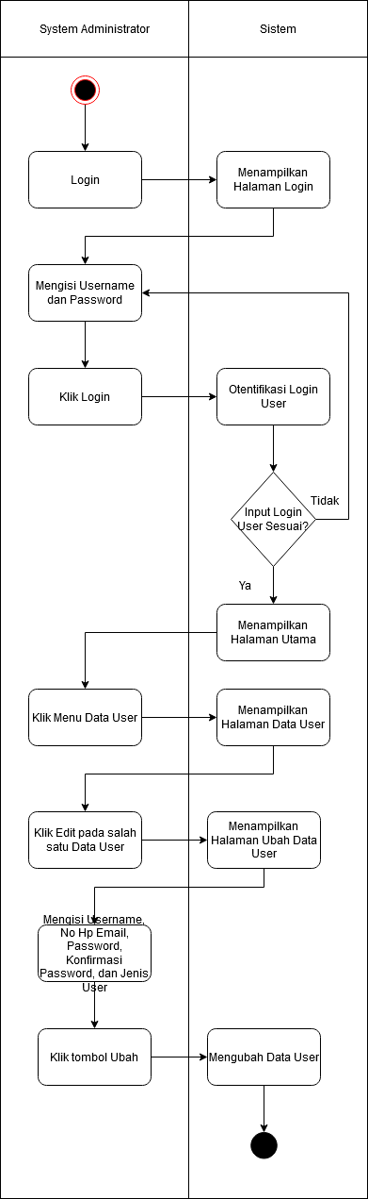

## Activity Diagram Menghapus Data User

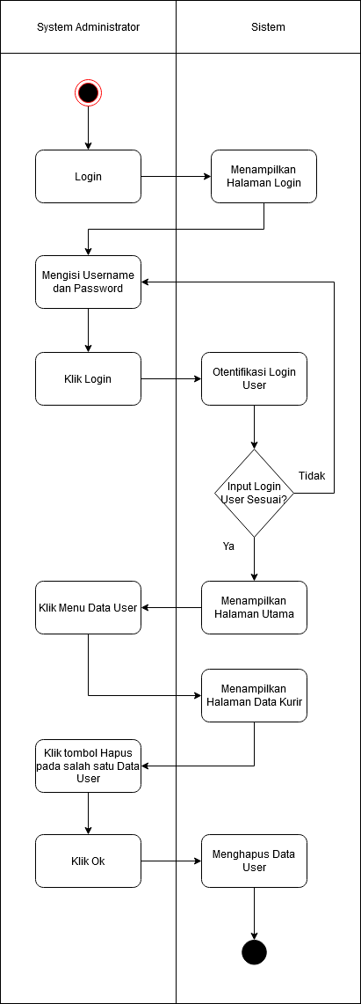

## Activity Diagram Login User

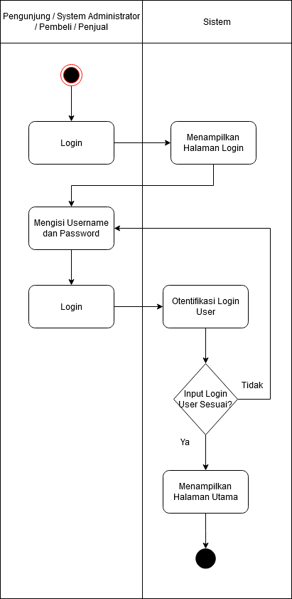

## Actitvity Diagram Pembelian

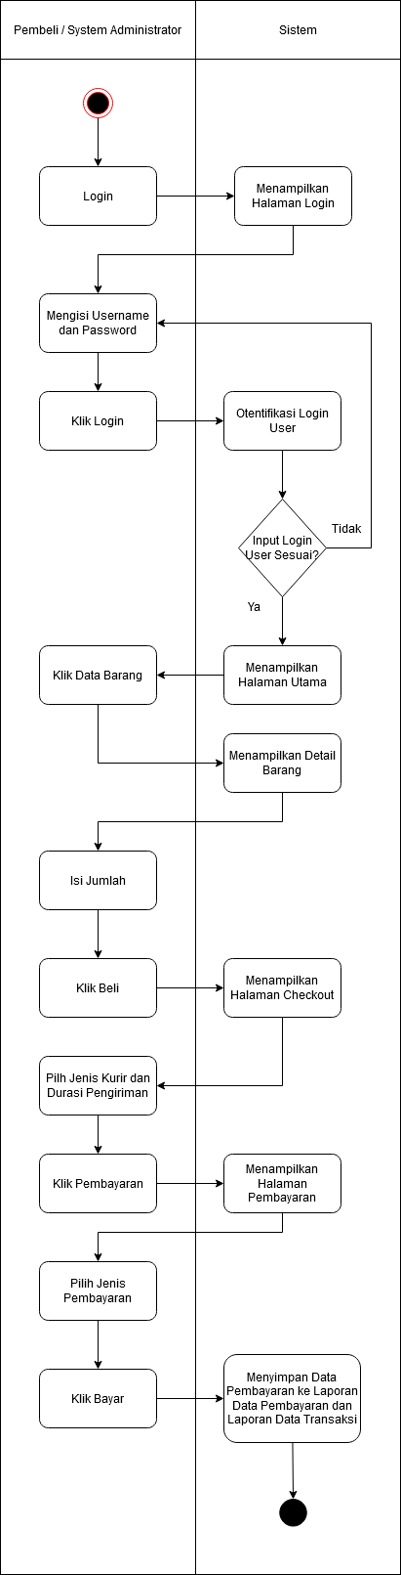

## Activity Diagram Menambah Data Barang

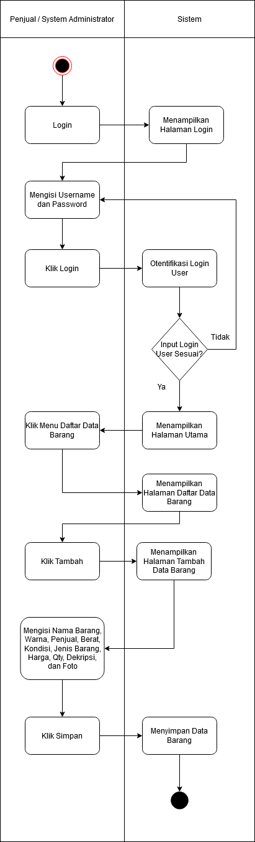

## Activity Diagram Mengubah Data Barang

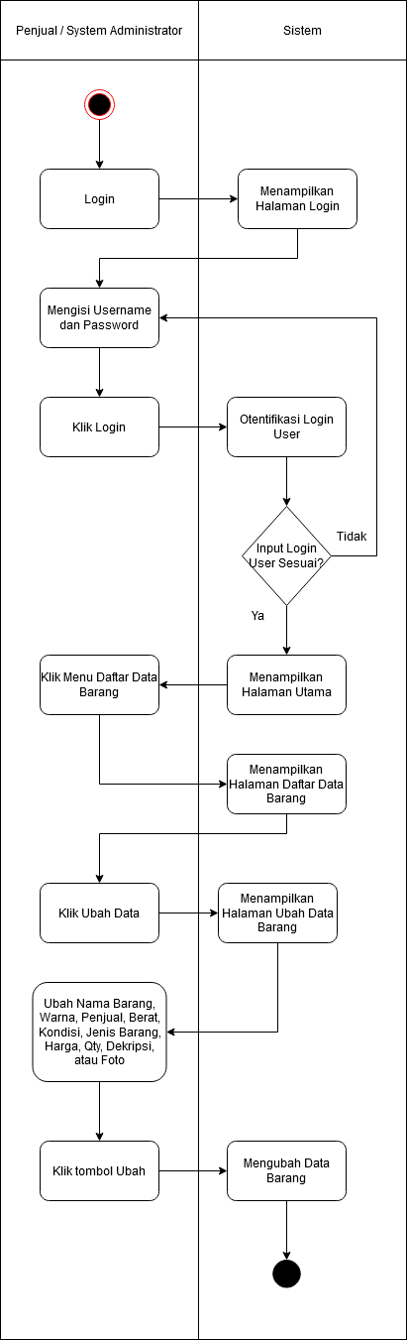

## Activity Diagram Menghapus Data Barang

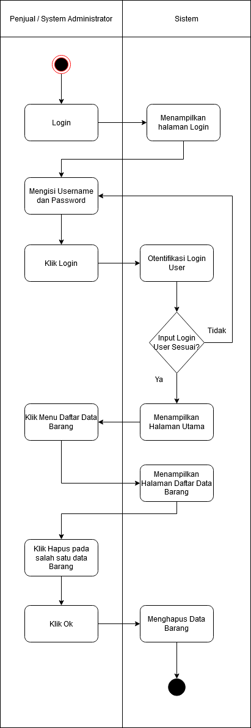

## Activity Diagram Melihat Data Transaksi

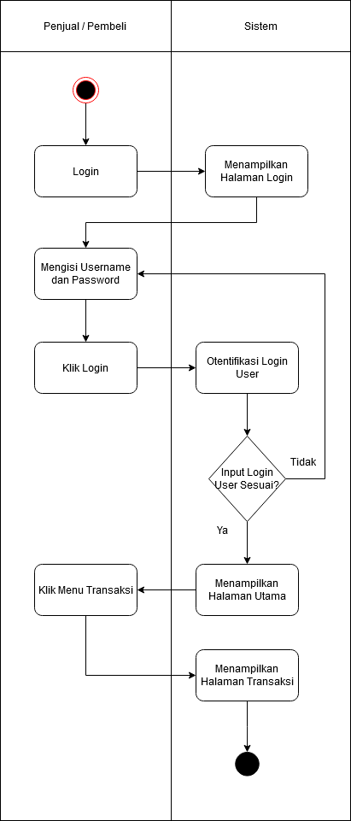

## Activity Diagram Retur Data Transaksi

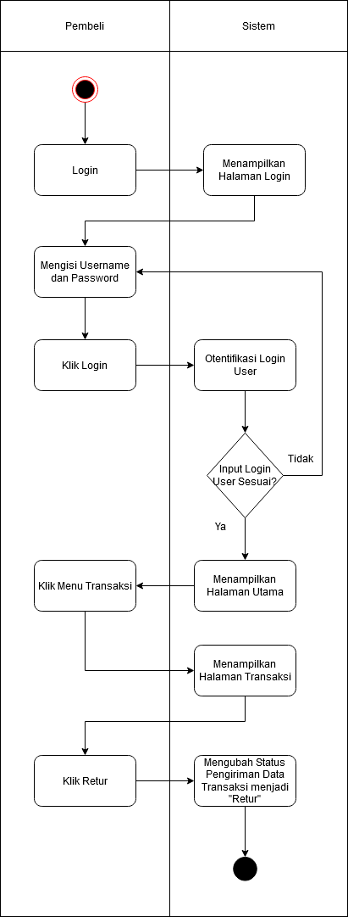

## Activity Diagram Terima Data Transaksi

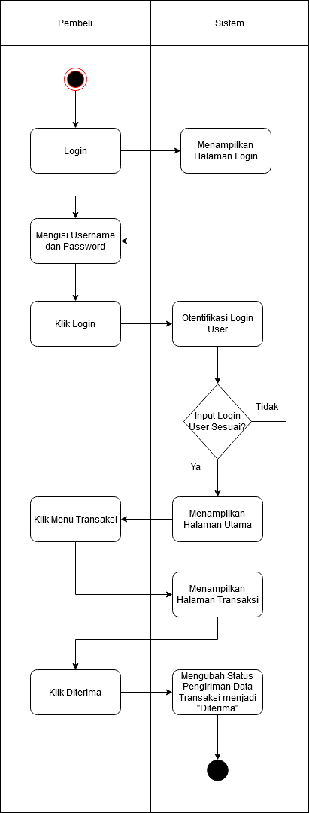

## Activity Diagram Ubah Status Pengiriman Data Transaksi

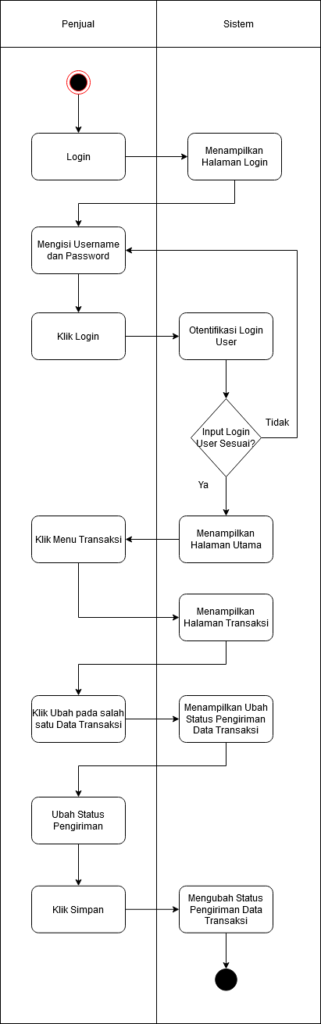

## Activity Diagram Melihat Data Laporan Transaksi

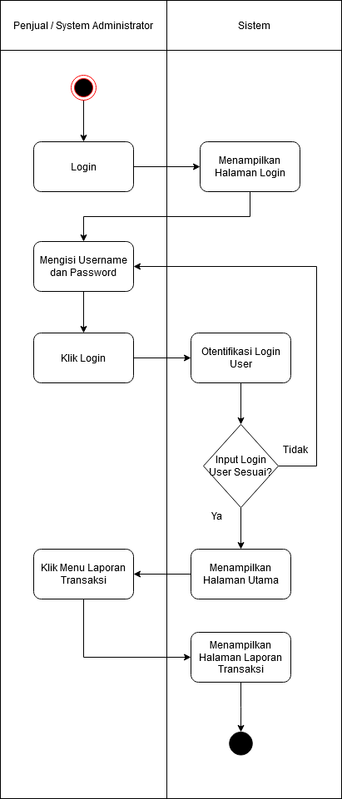

## Activity Diagram Mencetak Data Laporan Transaksi

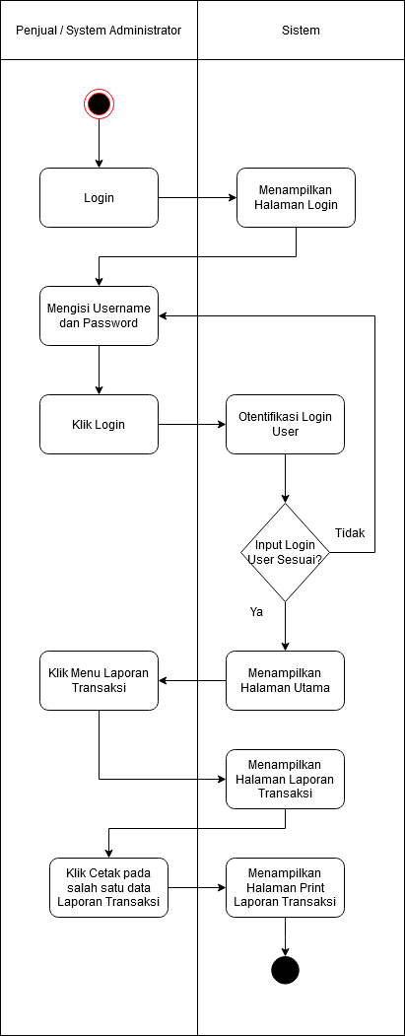

## Activity Diagram Melihat Data Laporan Pembayaran

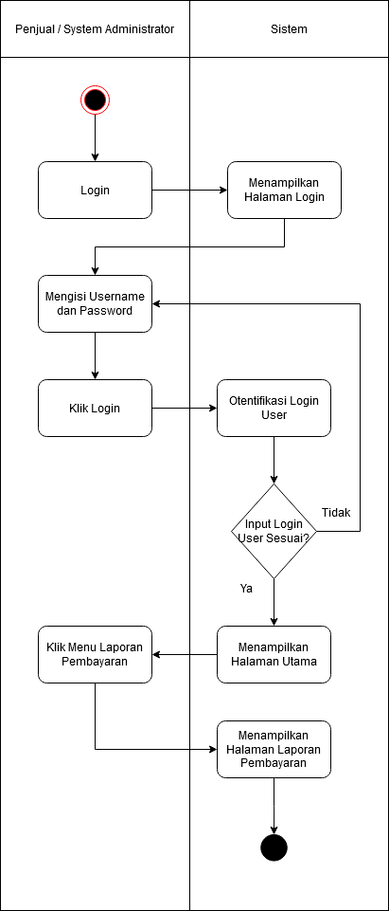

## Activity Diagram Mencetak data Laporan Pembayaran

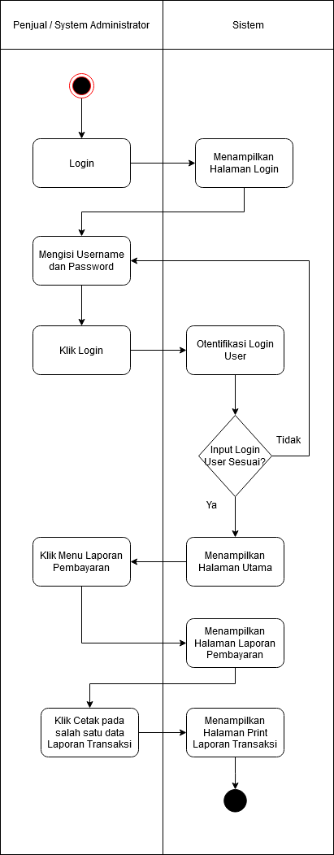

## Activity Diagram Melihat Data Kurir

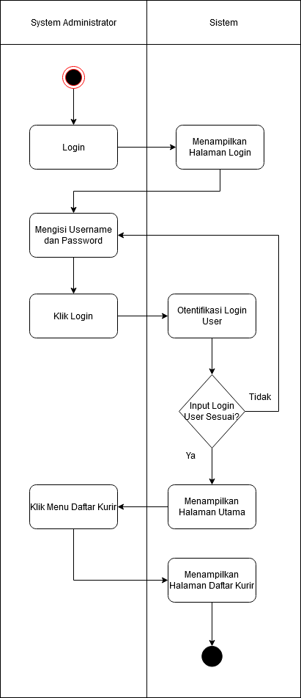

## Activity Diagram Menambah Data Kurir

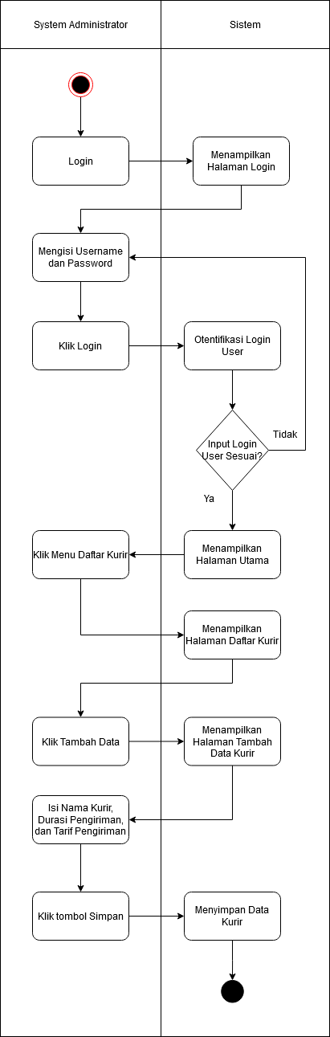

## Activity Diagram Mengubah Data Kurir

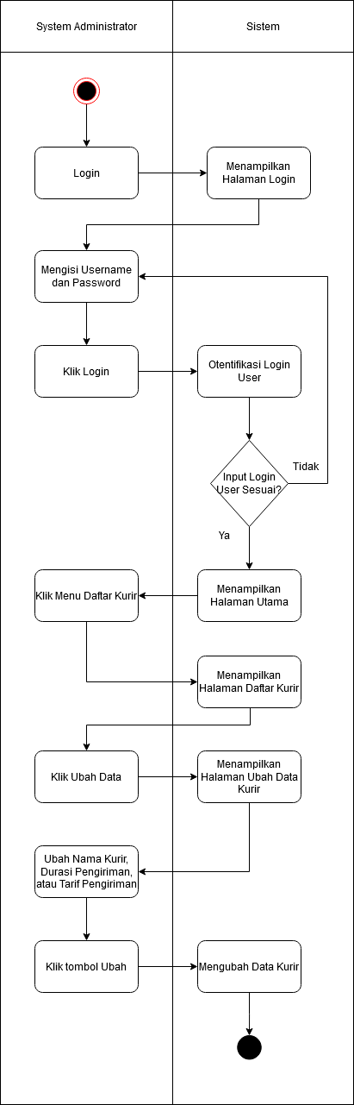

## 2.21 Activity Diagram Menghapus Data Kurir

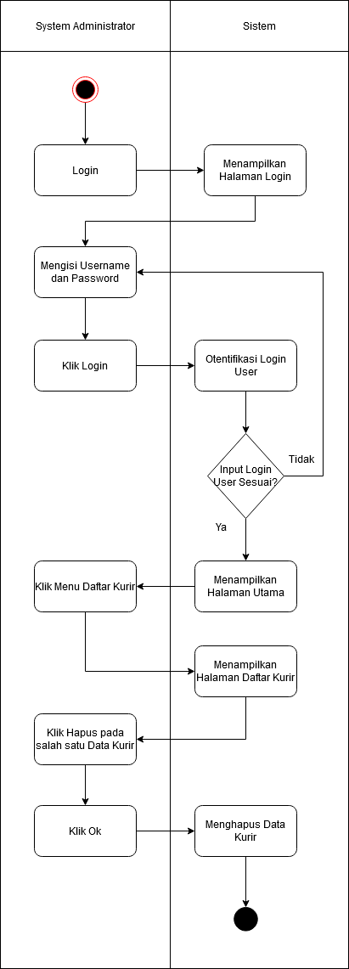

# Class Diagram

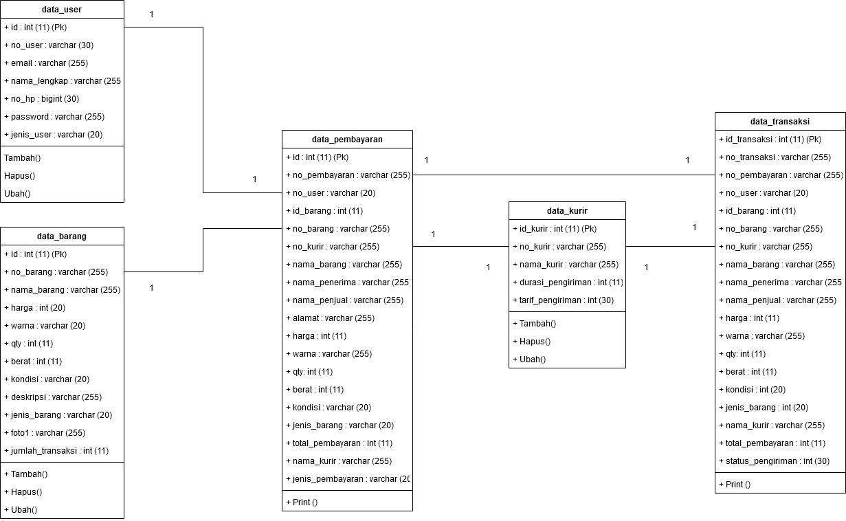

# Sequence Diagram

## Sequence Diagram Login

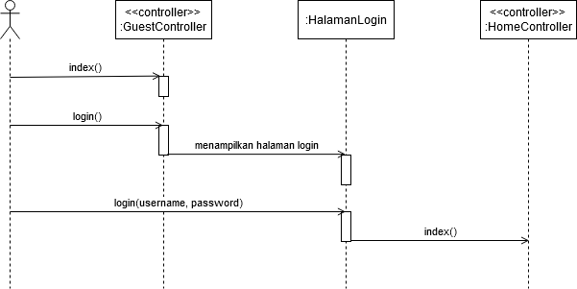

## Sequence Diagram Registrasi

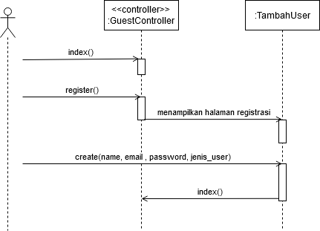

## Sequence Diagram Menambah Data User

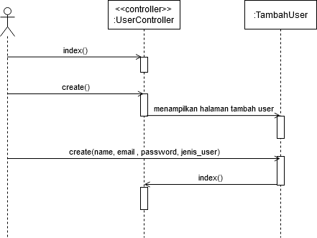

## Sequence Diagram Mengubah Data User

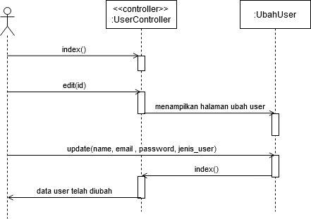

## Sequence Diagram Menghapus Data User

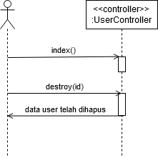

## Sequence Diagram Menambah Data Barang

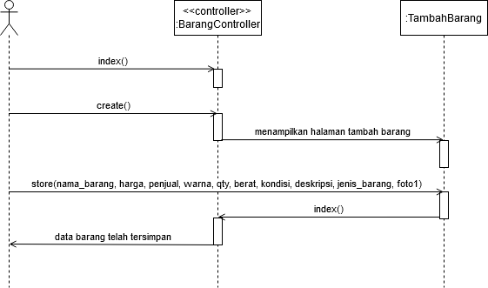

## Sequence Diagram Menambah Data Barang Penjual

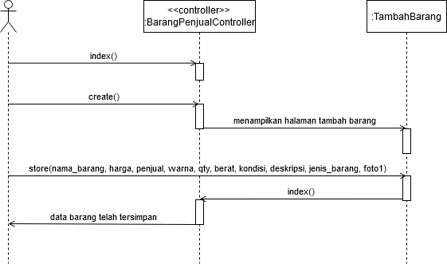

## Sequence Diagram Mengubah Data Barang

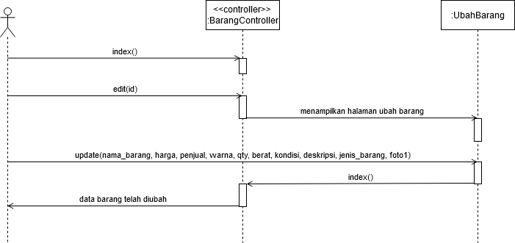

## Sequence Diagram Mengubah Data Barang Penjual

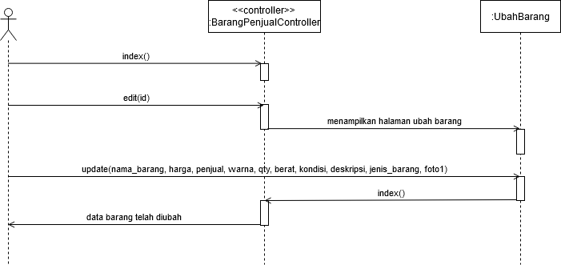

## Sequence Diagram Menghapus Data Barang

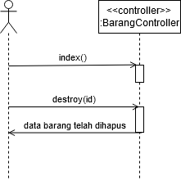

## Sequence Diagram Menghapus Data Barang Penjual

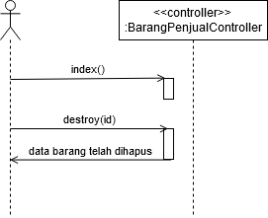

## Sequence Diagram Menambah Data Kurir

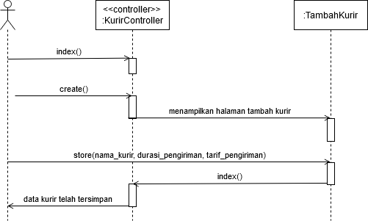

## Sequence Diagram Mengubah Data Kurir

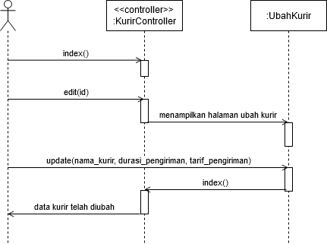

## Sequence Diagram Menghapus Data Kurir

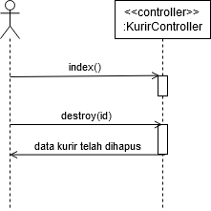

## Sequence Diagram Pembelian

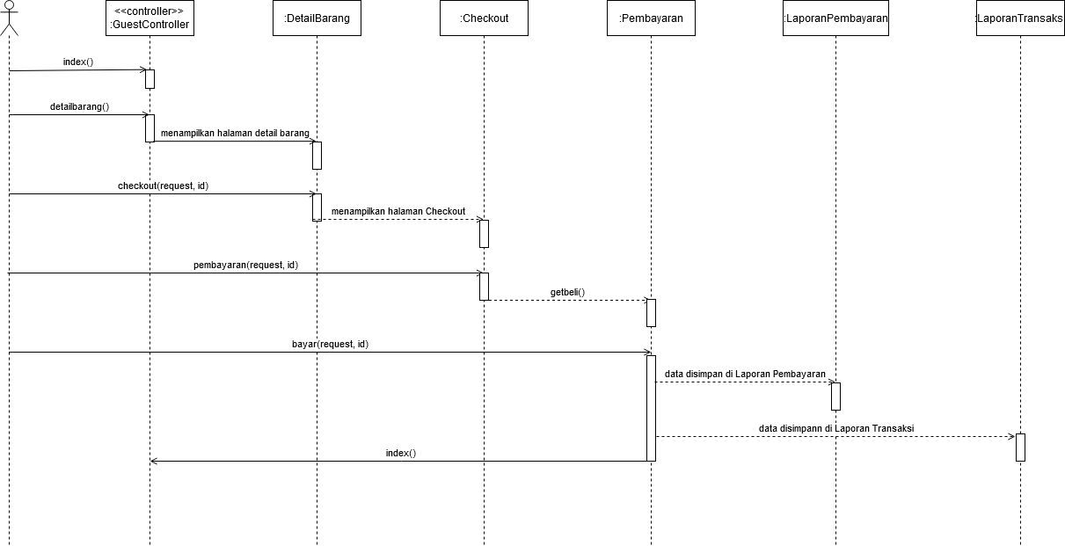

## Sequence Diagram Melihat Laporan Transaksi

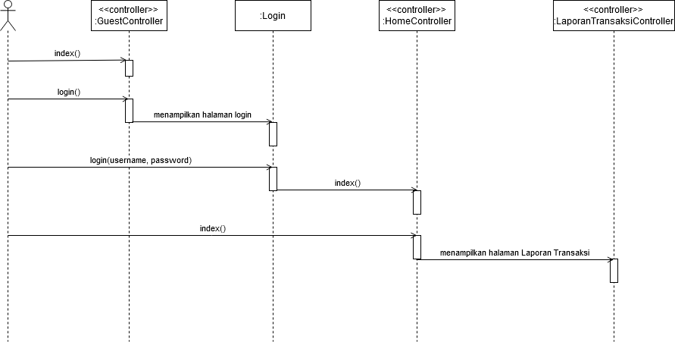

## Sequence Diagram Mencetak Laporan Transaksi

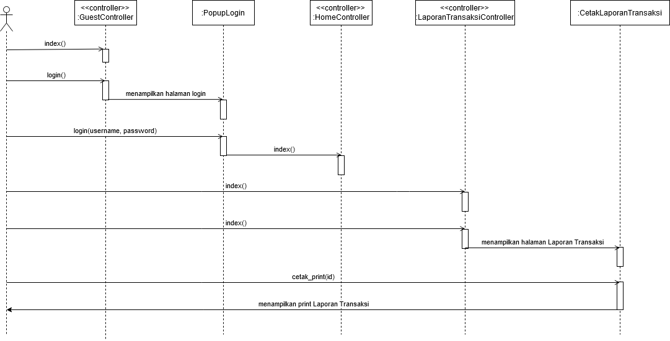

## Sequence Diagram Melhat Laporan Pembayaran

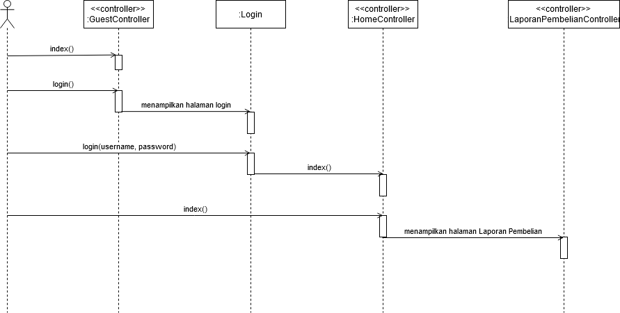

## Sequence Diagram Mencetak Laporan Pembayaran

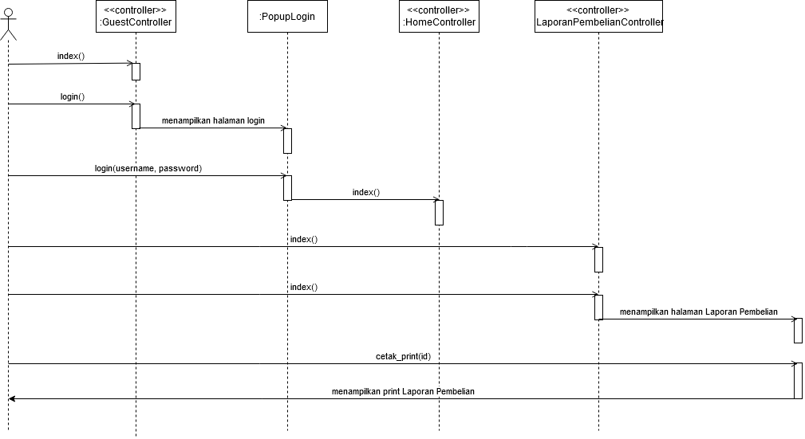

## Sequence Diagram Melihat Data Transaksi

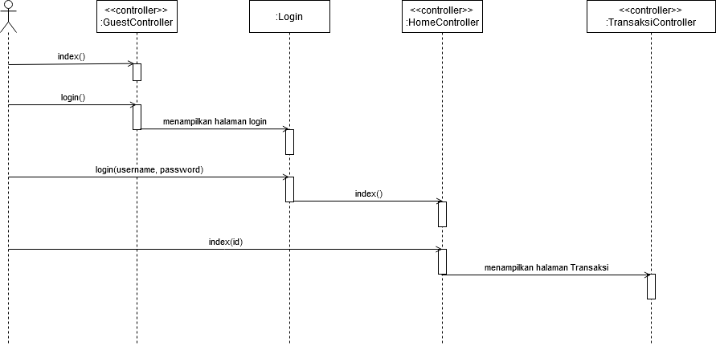

## Sequence Diagram Retur Data Transaksi

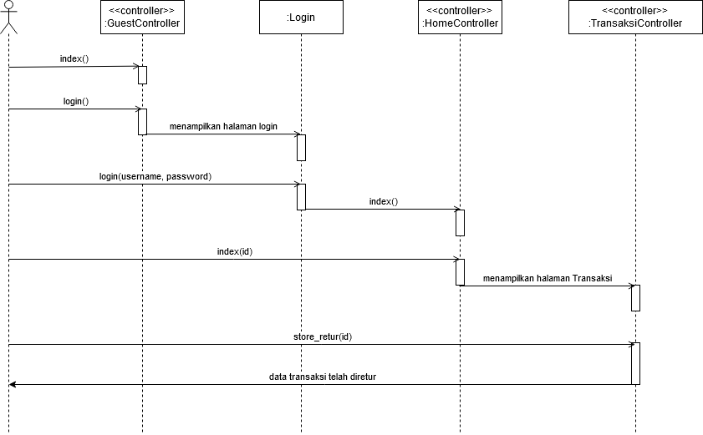

## Sequence Diagram Terima Data Transaksi

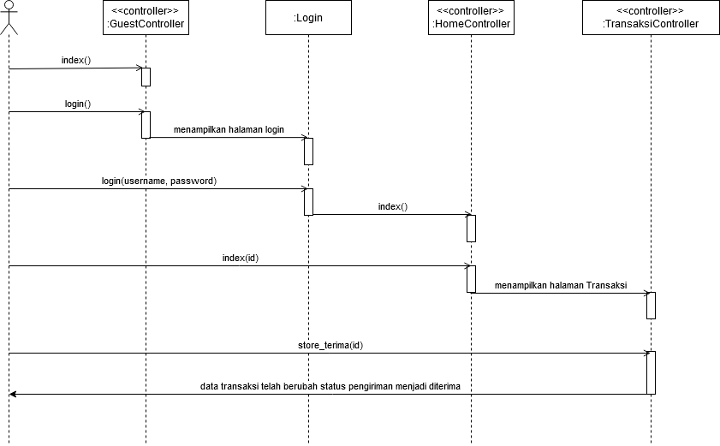

## Sequence Diagram Mengubah Status Pengiriman Data Transaksi

